Output Screenshots

1. Create a instance, connect to VM and install the Jenkins.

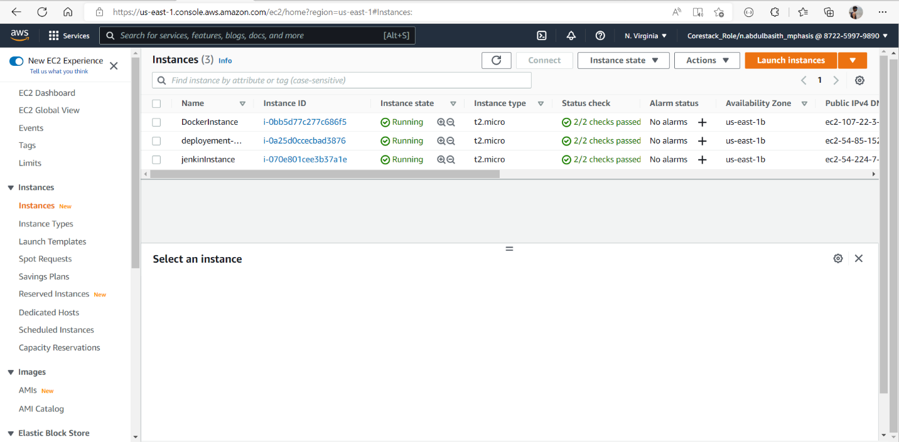

1. Get the password in the instance using command which given the Jenkins login page, and go to dashboard and add new item.

1. Create a new user in AWS account and get the user credential

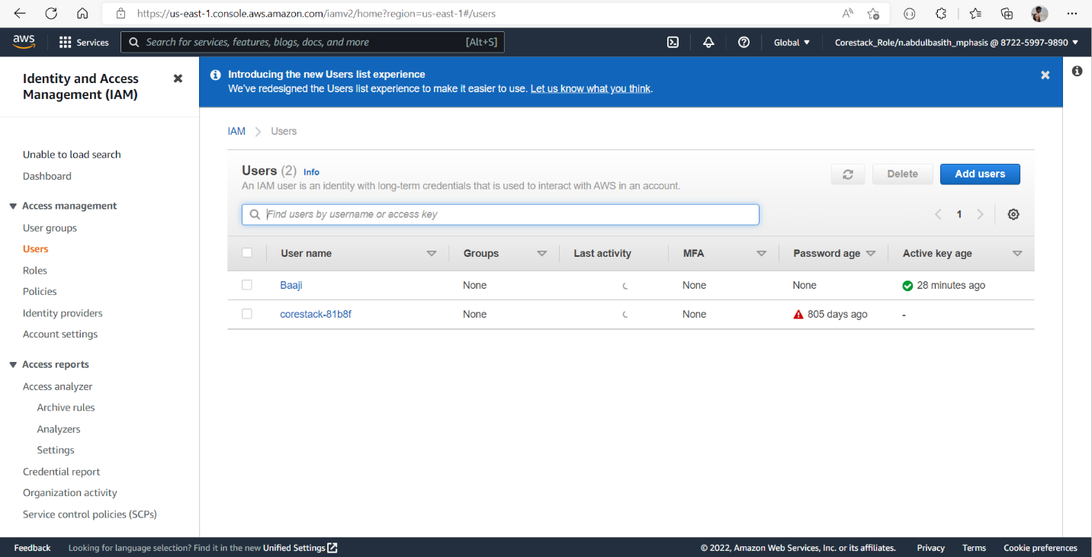

1. Go to the Jenkins dashboard => manage Jenkins => configure system and Add amazon s3 profile with user credential.

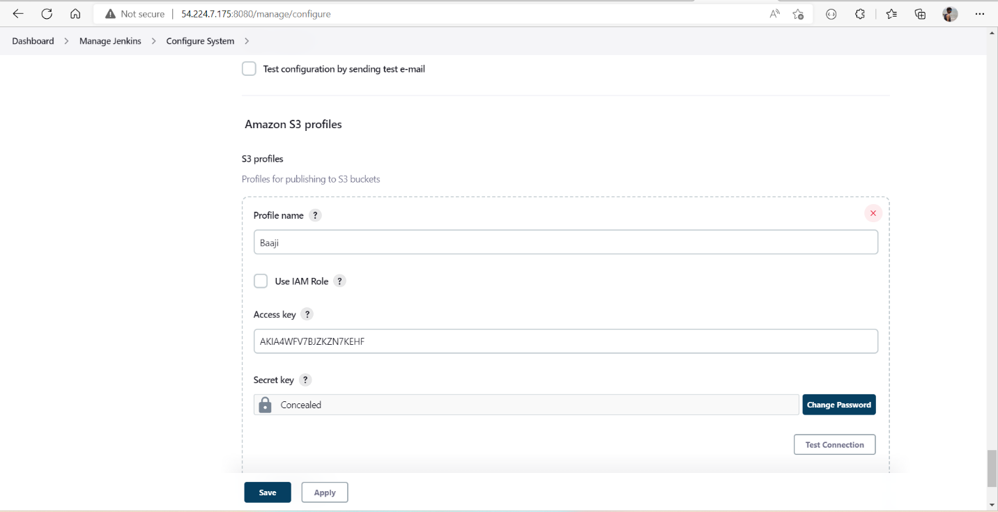

1. Create a repository in github and commit the code and add the github link in the Jenkins while creating new item.

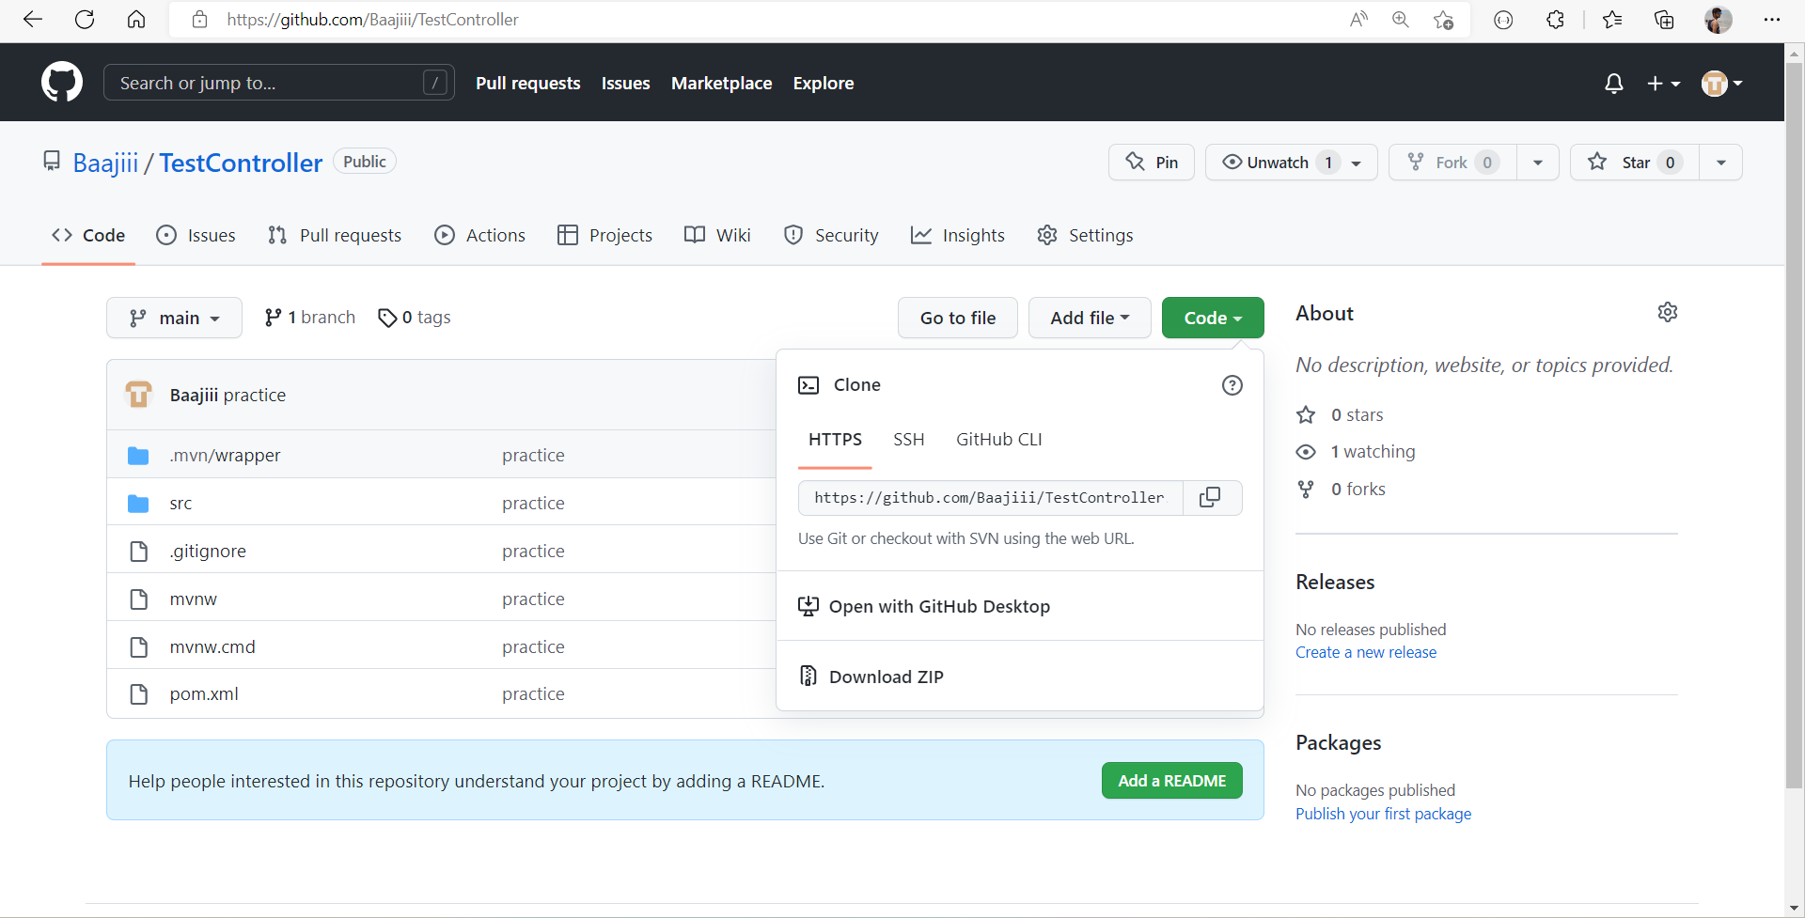

1. Create a S3 bugket in the AWS account.

1. After add the git hub link in the Jenkins, configure the Jenkins and select the new item was created and build it.

1. Create another instance to deploy the application in the cloud and connect to the VM and install the java 17 and install maven.

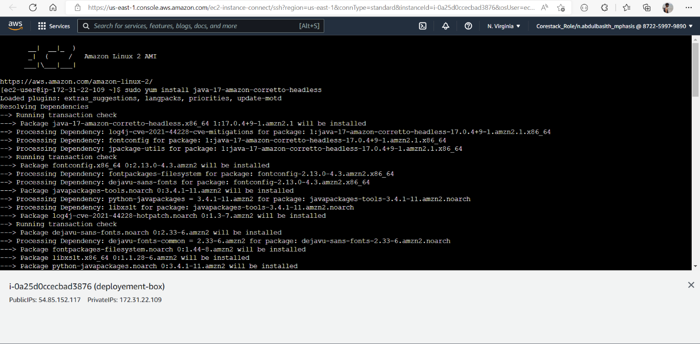

1. After that edit the inbound in the instance and add the port 8080.

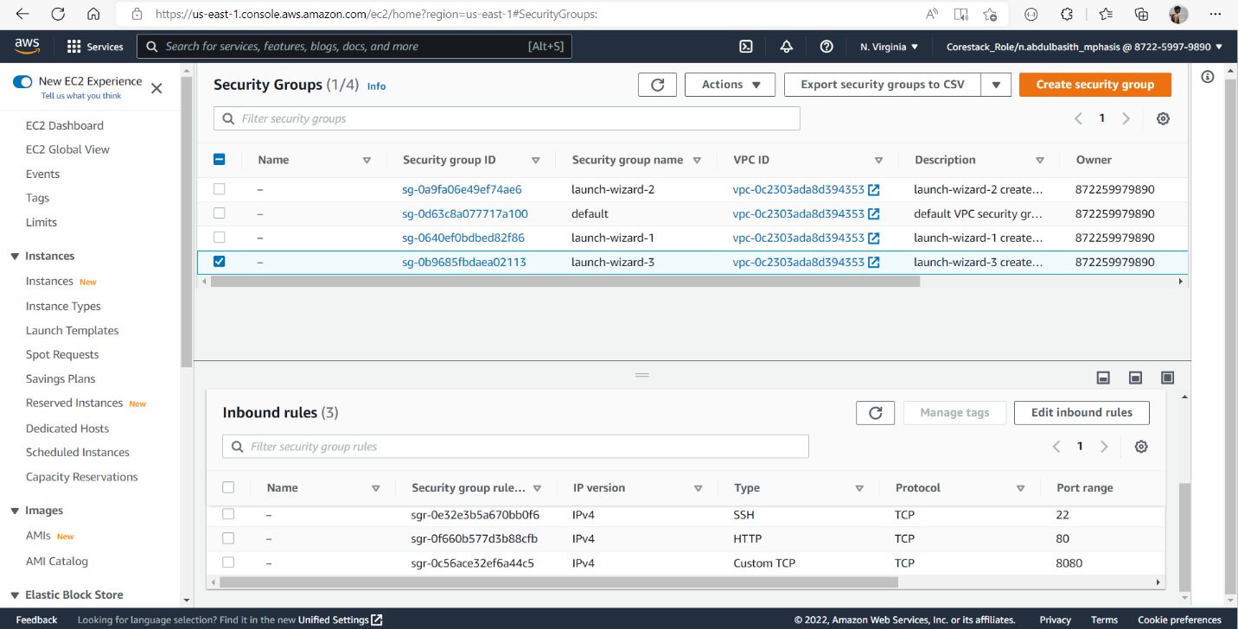

1. Create app in the VM and download the jar file from the S3 bugket and run the jar using commands .

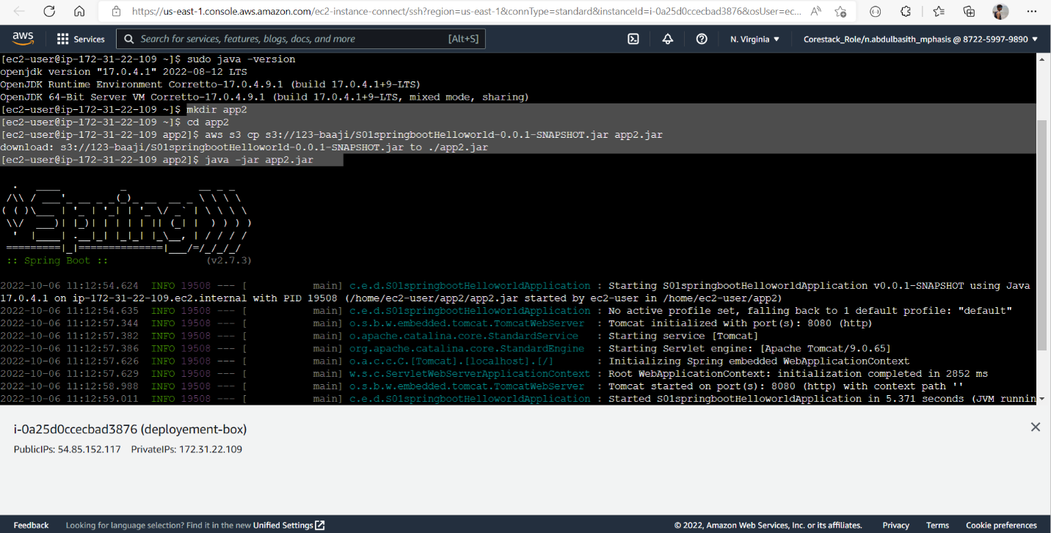

1. Copy the public ip address from the instance and paste in the browser url and add 8080 to the url , output will be display.



